

**Balance exercises**

Your balance can often be affected when you have Multiple Sclerosis (MS). You may notice you veer when walking or sway a little or sometimes trip or feel a bit dizzy. This symptom can be helped by exercising and specifically trying to re-train your balance systems. **NEVER** do an exercise that feels too difficult or that may cause you to fall; you may need to hold onto the back of a sturdy chair or the kitchen counter with one hand or just your fingertips when doing these exercises. To make any of the exercises more difficult you can try them with your eyes closed or on a different surface like a pillow.

**Tandem Stance Balance**

* Stand with one foot ahead of the other, heel in front of the toes and keep steady.
* Hold this position for 30 seconds.
* Alternate the foot position and repeat.
* Hold for 30 seconds
* Repeat five times
* Complete one set per day

**Single-Leg Stance**

* Stand on one leg and maintain your balance for 30 seconds.
* Repeat on the other side.
* Hold for 30 seconds
* Repeat five times
* Complete one set per day



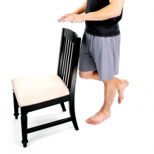

**Single-Leg Stance – Clocks Drill**

Stand on one leg and tap your other foot forward, sideways and behind you as if tapping to the different numbers on a clock face.

* Repeat five times on both sides.
* Complete one set per day

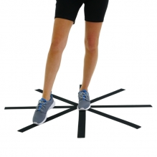

If you need more specific advice and treatment about certain symptoms, ask your team in the MS Unit about accessing the physiotherapy service here in the hospital (Tel: (01) 416 2503) or ask your GP to refer you to your local primary care physiotherapist.